SQL vs MySQL: What's the Difference?

What is SQL?
SQL is a language which is used to operate your database. SQL is the basic language used for all the databases. There are minor syntax changes amongst different databases, but the basic SQL syntax remains largely the same. SQL is a short abbreviation of Structured Query Language. According to ANSI (American National Standards Institute), SQL is the standard language to operate a relational database management system.
SQL is used in the accessing, updating, and manipulation of data in a database. Its design allows for the management of data in an RDBMS, such as MYSQL. SQL language also used for controlling data access and for creation and modification of Database schemas.

What is MYSQL?
Developed in the mid-90s., MySQL was one of the first open-source database available in the market. Today there are many alternatives variants of MySQL,. However, the differences between the variants are not significant as they use the same syntax, and basic functionality also remains same.
MySQL is an RDBMS that allows keeping the data that exists in a database organized. MySQL is pronounced as "My S-Q-L," but it is also called "My Sequel." It is named after co-founder Michael Widenius' daughter. MySQL provides a multi-user access to databases. This RDBMS system is used with the combination of PHP and Apache Web Server, on top of a Linux distribution. MySQL uses the SQL language to query the database.
Now let see the Difference between SQL and MySQL
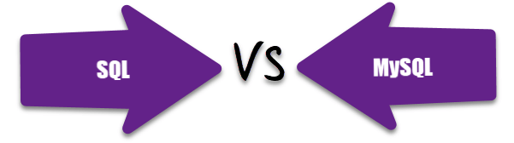

Difference between SQL and MySQL
Parameter | SQL | MYSQL
Definition | SQL is a Structured Query Language. It is useful to manage relational databases. | MySQL is an RDBMS tostore, retrieve, modify and administrate a database usingSQL.
Complexity | You need to learn the SQL language to use it effectively. | It is readily available through download and installation.
Type | SQL is a query language. | MySQL is database software. It used "SQL" language to query the database.
Support for connector | SQL does not provide connectors. | MySQL offers an integrated tool called 'MySQL workbench' to design and develop databases.
Purpose | To query and operate database system. | Allows data handling, storing, modifying, deleting in a tabular format.
Usage | SQL code and commands are used in various DBMS and RDMS systems including MYSQL. | MYSQL is used as an RDBMS database.
Updates | The language is fixed, and command remains the same. | Get the frequent updates

KEY DIFFERENCE:
- SQL is a language which is used to operate your database whereas MySQL was one of the first open-source database available in the market
- SQL is used in the accessing, updating, and manipulation of data in a database while MySQL is an RDBMS that allows keeping the data that exists in a database organized
- SQL is a Structured Query Language and MySQL is a RDBMS to store, retrieve, modify and administrate a database.
- SQL is a query language while MYSQL is a database software

- Prev Report a Bug
- Next

SQL Tutorials
- 24) JOINS
- 25) Views
- 26) Indexes
- 27) PHP MySQL Example
- 28) Oracle MySQL 5.6 Certification
- 29) SQL vs MySQL
- 30) SQL Management Tools
- 31) SQL Certification Courses
- 32) SQL Cheat Sheet
- 33) SQL Interview Q & A
- 34) SQL Tutorial PDF

/div>

